Project Design Phase-II
Technology Stack (Architecture & Stack)

Date | 06 February 2026
Team ID | LTVIP2026TMIDS66199
Project Name | TransLingua: AI-Powered Multi-Language Translator
Maximum Marks | 4 Marks

Technical Architecture:
The Deliverable shall include the architectural diagram as below and the information as per the table1 & table 2
Reference: https://developer.ibm.com/patterns/ai-powered-backend-system-for-order-processing-during-pandemics/

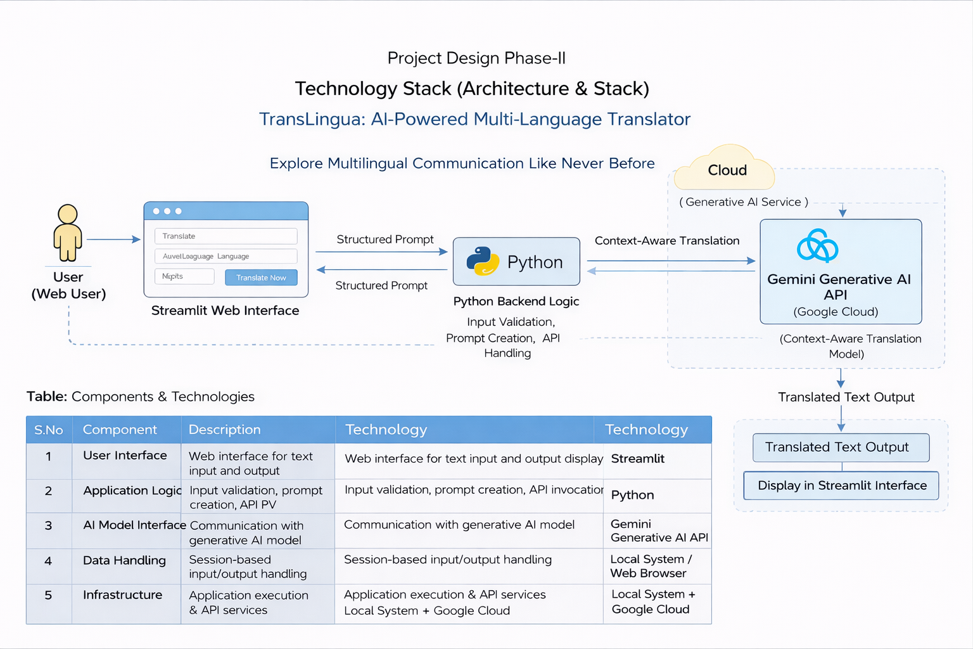

Table-1 : Components & Technologies:
S.No | Component | Description | Technology
1 | User Interface | Web interface for entering travel details and viewing results | Streamlit
2 | Application Logic | Input validation, prompt creation, API invocation | Python
3 | AI Model Interface | Communication with generative AI model | Google Generative AI API (Gemini)
4 | Data Handling | Temporary session-based input data | Streamlit session handling
5 | External API | Generative AI service for multiple language creation | Gemini Flash Model
6 | Infrastructure | Application execution environment | Local System / Web Browser

Table-2: Application Characteristics:
S.No | Characteristic | Description | Technology
1 | Open-Source Frameworks | Used for UI and backend development | Python, Streamlit
2 | Security Implementations | API key protection and input validation | Secure API configuration, Input Validation
3 | Scalable Architecture | Easily extendable to include new features | Modular Python Architecture
4 | Availability | Accessible when application server is running | Streamlit Server
5 | Performance | Real-time AI response generation | Optimized API call handling

References:
https://c4model.com/
https://developer.ibm.com/patterns/online-order-processing-system-during-pandemic/
https://www.ibm.com/cloud/architecture
https://aws.amazon.com/architecture
https://medium.com/the-internal-startup/how-to-draw-useful-technical-architecture-diagrams-2d20c9fda90d

